Data Quality
Introduction to DQ
The source file 'car_prices.parquet' provided in Parquet format was successfully transformed into a flat CSV file. The conversion was performed using Python's Pandas library paired with the PyArrow engine:
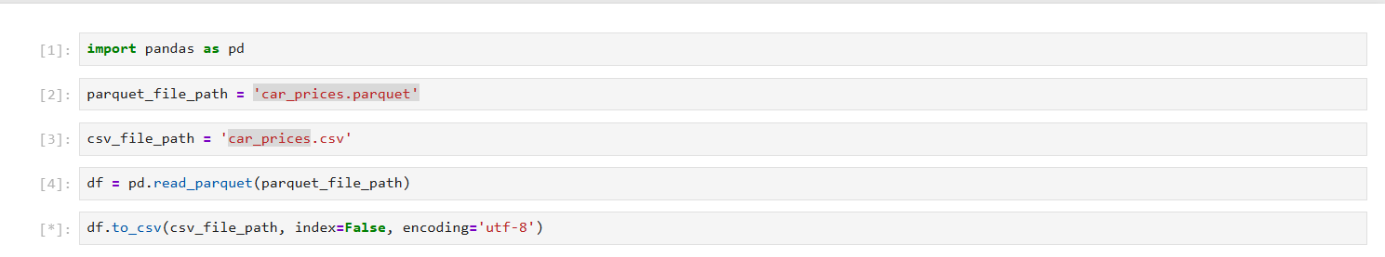
The resulting CSV file is fully optimized for subsequent analysis and reporting.
Section 1 – File Size Comparison: car_prices.parquet vs. car_prices.csv
1. Size Metrics
- car_prices.parquet: Heavily compressed binary file (17,313 KB).
- car_prices.csv: Uncompressed plain text file (90,328 KB).
The reduction in Parquet's file size is caused by four main architectural advantages:
- Columnar Storage Layout: Unlike CSV, which stores data row-by-row, Parquet organizes data column-by-column. Grouping identical data types together allows the system to pack information much more tightly.
- Built-in Compression: Parquet natively applies advanced compression algorithms directly to individual columns, which is far more efficient than compressing mixed-type rows.
- Dictionary Encoding: The dataset contains highly repetitive text values. CSV duplicates these text strings every time, whereas Parquet replaces them with tiny bit-packed integers linked to a small background lookup dictionary.
- Binary vs. Text Storage: CSV stores numbers as text characters (where every digit takes up space). Parquet stores numeric values in a compact, fixed-size binary format, preventing character inflation.
Section 2 – Bank and car_prices datasets overview
Bank Dataset Analysis: This dataset will be analyzed using manual data exploration and filtering in Microsoft Excel. Excel was chosen because the dataset is compact and easy to navigate within a spreadsheet layout ($4,522$ rows and $10$ columns), allowing for immediate visual validation and quick ad-hoc filtering.
Car Prices Dataset Analysis: This dataset has been selected for querying and analysis using SQL. SQL was chosen specifically due to the dataset's significantly larger size ($558,838$ rows and $16$ columns). Handling a volume of this scale in Excel would cause severe performance lags and stability issues, whereas an SQL database engine provides the scalability required for fast aggregations.
Bank Dataset Description
Contained Information: The dataset contains client demographic details (age, job, marital, education) and financial status indicators (default, balance, housing, loan), along with communication metrics such as communication contact type and call duration.
Business Utility: This data can be used by financial institutions for Targeted Marketing (predicting which customer segments are most likely to accept product offers based on their profile) and Credit Risk Assessment (evaluating a client's financial stability and loan eligibility using their balance and existing liabilities).
Car Prices Dataset Description
Contained Information: The dataset contains vehicle specifications (year, make, model, trim, body, transmission,vin and color) and condition metrics of vehicle (condition, odometer), along with market transactional data such as geographic state, seller, market value estimation (mmr), final selling price, and sale date.
Business Utility: This data can be used by automotive businesses for Predictive Valuation (estimating fair market resale prices and trade-in values based on car condition and mileage) and Inventory Optimization (analyzing market demand and price depreciation trends across different regions to stock high-margin vehicles).
Section 3 – Data anomalies report
Bank Dataset
ID | Data anomaly | Reason | Steps to Reproduce | Attachments
1 | Invalid Age Values | The age column contains physically impossible values for living bank clients (e.g., -11) and extreme values like 144, 132, 192, and 200. Human lifespan limits and banking regulations make these numbers invalid data entries. | Anomaly was found using data filters on the header row “age” sorting the age column in ascending/descending order | Figure 1
2 | Invalid Job Category ("boogieman") | The job column contains the value "boogieman", which is a fictional character and not a valid human occupation. This indicates the presence of corrupted, mock, or uncleaned test data within the production dataset. | Anomaly was found using data filters on the header row “job” | Figure 2
3 | Invalid Education Level ("Duck") | The education column contains the value "Duck". This is completely invalid as it does not represent any recognized human educational degree or level (like primary, secondary, etc.), indicating corrupt data or poor input validation. | Anomaly was found using data filters on the header row “education” | Figure 3
4 | Inconsistent Categorical Values ("N" vs "no") in default column | The column contains both "no" and "N" text values. This represents a lack of data standardization (likely caused by blending data from different source systems), which splits the same logical category into two separate variations. | Anomaly was found using data filters on the header row “default” | Figure 4
5 | Critical Logical Conflict: Negative Balance without any Active Credit Lines | Multiple records show negative accounts (balance < 0) while both loan and housing columns are marked as "no". A bank account cannot have an overdraft or debt balance if the client has zero active credit or housing products, proving an underlying database sync failure. | Balance column was filtered by number filters “less than 0”. Loan column was filtered by value "no", housing column was filtered by value "no" | Figure 5
6 | Suspicious High Balance with Active Multiple Debts | Multiple records show substantial positive accounts (balance > $9,000) while simultaneously carrying both active housing and loan liabilities. This introduces a business logic risk, likely indicating a data synchronization lag where loan payoff statuses were not updated to "no". | Balance column was filtered by number filters “above average”. Loan column was filtered by value "yes", housing column was filtered by value " yes " | Figure 6
7 | Inconsistent Missing Data Placeholders ("NA", "Unkn", "unknown") in contact column | The contact column uses multiple redundant variations to represent missing or unavailable communication types. This lack of standardization splits what should be a single "missing data" category into three distinct values, causing fragmentation during analytical grouping. | Anomaly was found using data filters on the header row “contact” | Figure 7
8 | Negative Duration Values | The duration column contains multiple records with a value of -999. Time logs cannot be negative; this is a clear database error or an unhandled missing data code. | Anomaly was found using data filters on the header row “age” sorting the age column in ascending/descending order | Figure 8
9 | Extreme Call Duration Outliers | The duration column contains extreme positive values exceeding 1000 seconds (with maximums up to 3025 seconds, which equals ~50 minutes). These long durations represent extreme statistical outliers, likely caused by system logging hanging or improper call termination by the agent. | Duration column was filtered with the condition "Greater Than 1000". | Figure 9
10 | Critical Logical Failure: Single-Digit Age with Active Employment & Marriage Status | Multiple records show impossible age values between 3 and 7 years old. These fields contain severe logical conflicts, listing toddlers as married/divorced, employed (e.g., "technician"), and holding active housing mortgages (housing = "yes"). This points to a major database shift or uncleaned test entries. | Anomaly was found using data filters on the header row “age” sorting the age column in ascending/descending order. Cross-reference the resulting rows with the job, marital, and housing columns to observe the systemic logical errors. | Figure 10

Figure 1 - Invalid Age Values
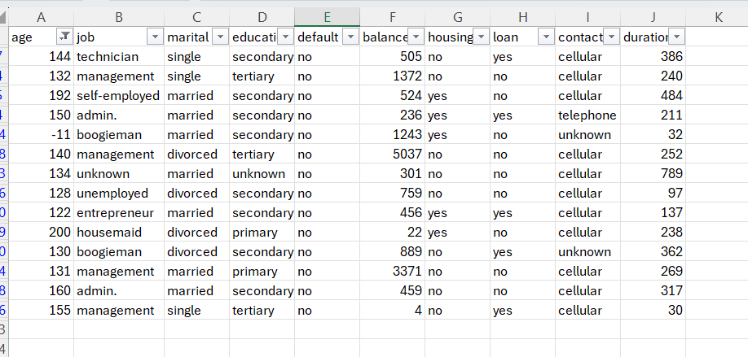
Figure 2 - Invalid Job Category ("boogieman")
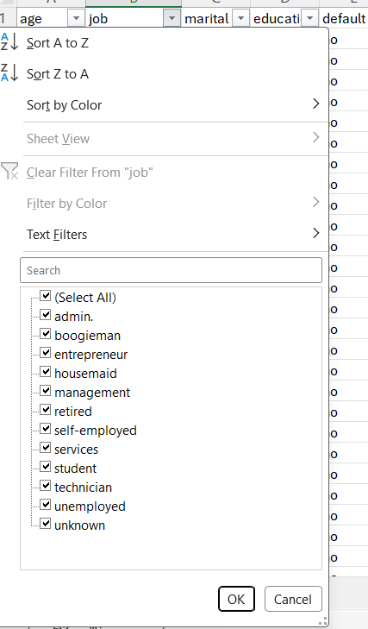
Figure 3 - Invalid Education Level ("Duck")
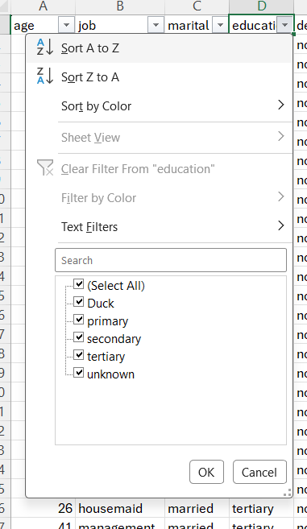
Figure 4 - Inconsistent Categorical Values ("N" vs "no") in default column
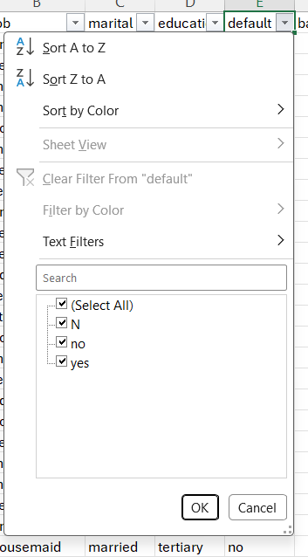
Figure 5 - Critical Logical Conflict: Negative Balance without any Active Credit Lines
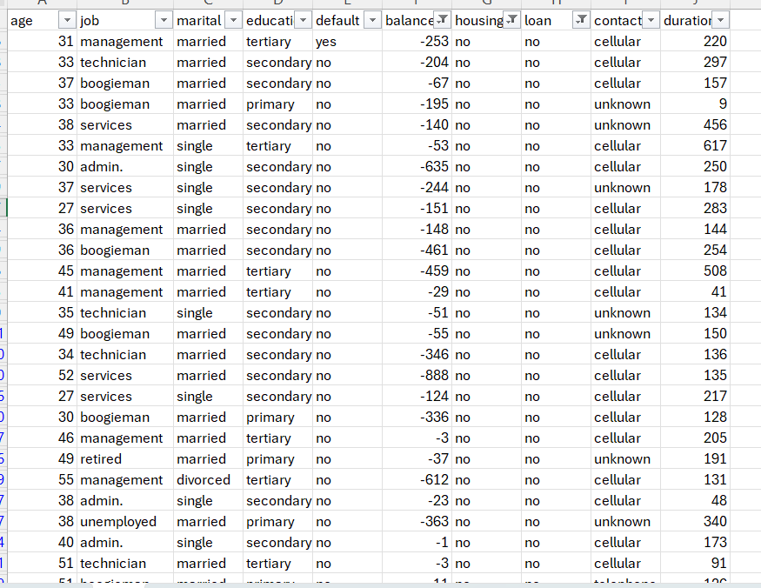
Figure 6 - Suspicious High Balance with Active Multiple Debts
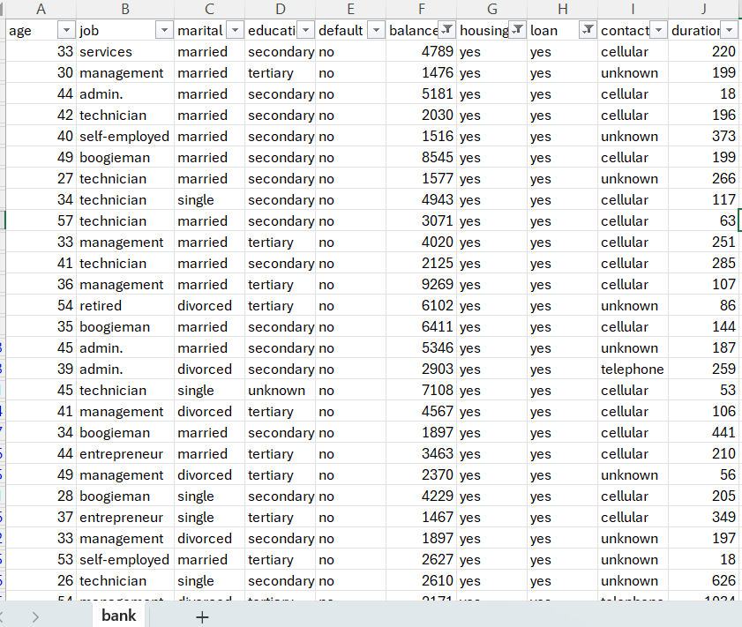

Figure 7 - Inconsistent Missing Data Placeholders ("NA", "Unkn", "unknown") in contact column
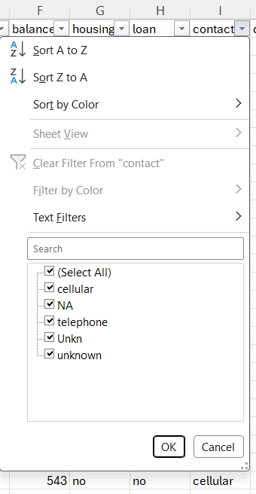
Figure 8 - Negative Duration Values
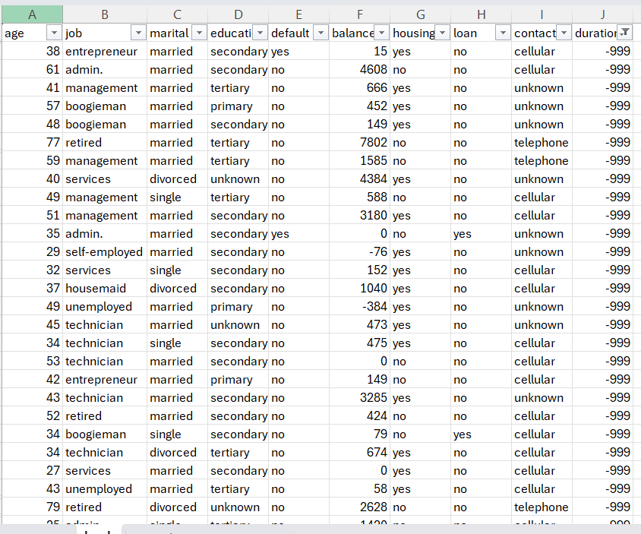
Figure 9 -Extreme Call Duration Outliers

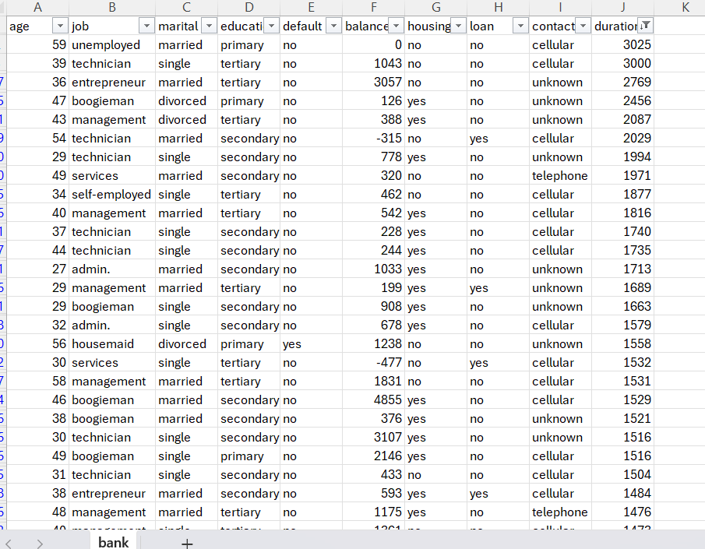
Figure 10 - Critical Logical Failure: Single-Digit Age with Active Employment & Marriage Status
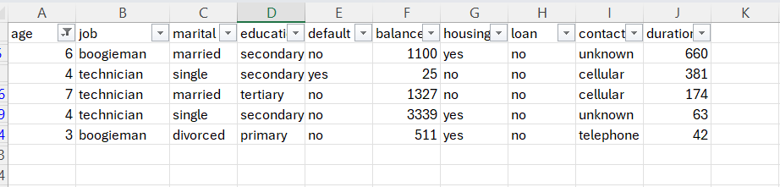
A comprehensive Data Quality (DQ) assessment was conducted on the provided Bank Marketing dataset to evaluate its integrity, consistency, and readiness for subsequent business intelligence reporting and predictive modeling. The analysis revealed a significant number of data anomalies, logical contradictions, and system-generated artifacts across both numerical and categorical fields. Leaving these anomalies unaddressed introduces severe risks to business operations and analytical accuracy. While the dataset possesses valuable consumer insights, immediate data cleansing (ETL/Data Prep phase) is mandatory before deploying any analytical assets or dashboards.
To systematically isolate and document data anomalies, several exploratory data analysis (EDA) and data profiling techniques were applied using Microsoft Excel filtering and sorting engines:
- Boundary Value Analysis (BVA): Utilized to scan the extremes of numerical variables (age, balance, duration), which successfully exposed physically impossible values and system placeholders.
- Cross-Field Logical Validation: Performed relational integrity checks between interdependent attributes (e.g., cross-referencing balance against credit lines like loan and housing, and verifying age against job and marital statuses).
- Categorical Standard Checking: Inspected unique value distributions across structural text fields to detect layout inconsistencies, redundant placeholders, and spelling corruptions.
Car Prices dataset
Dataset was uploaded to a PostgreSQL database for comprehensive analytical processing.
ID | Сolumn | Data Anomaly | Reason (Business Logic Justification) | Steps to Reproduce (SQL Script) | Attachments
1 | Make | Inconsistent Text Casing and Naming Standards (make column) | The make column lacks text standardization. In automobile manufacturing and sales analytics, brand names are unique master entities. The column contains duplicate entries due to mixed casing (e.g., 'acura' vs 'Acura', 'bmw' vs 'BMW') and inconsistent naming variations for the same manufacturer (e.g., 'chevrolet', 'Chevrolet', and 'chev truck'). This fragments data during aggregations. | SELECT DISTINCT make FROM car_prices; | Figure 1
2 | Make | Missing Values (Nulls/Blanks) in Critical Dimension "Make" | The dataset contains records with completely missing or blank values in the make column (visible as an empty string in distinct results), violating database completeness rules for primary analytical entities. | SELECT COUNT(*) FROM car_prices WHERE make IS NULL OR make = ''; | Figure 2
3 | Model | Format Corruption: Vehicle Models Converted to Dates ("09-Mar", "09-May") | The model column contains corrupted date values like "09-Mar" and "09-May". This data is fully corrupted because a spreadsheet application interpreted hyphenated or numeric model names as calendar formats, permanently erasing the actual commercial vehicle names upon ingestion. | SELECT DISTINCT model FROM car_prices WHERE model LIKE '%-%'; | Figure 3
4 | Model | Categorical Duplication via Lowercase Inconsistency in Models | The model column lacks text standardization. In automobile manufacturing and sales analytics, model names are unique master entities. The column contains duplicate model entries due to mixed casing (e.g., "corolla" and "Corolla", or "corvette" and "Corvette"), which splits identical vehicle line metrics. | SELECT DISTINCT model FROM car_prices; | Figure 4
5 | Model | Missing Values (Nulls/Blanks) in Critical Dimension model | The dataset contains records with completely missing or blank values in the model column (visible as an empty string in distinct results), violating database completeness rules for primary analytical entities. | SELECT COUNT(*) FROM car_prices WHERE model IS NULL OR model = ''; | Figure 5
6 | Trim | Suspicious Data Truncation and Low-Character Artifacts (e.g., trim = "4") | In automotive master data management, an isolated single-digit string like "4" or technical noise such as "!" and "+" inside a trim attribute contains absolutely zero business or semantic meaning. A car's equipment package cannot logically be described by a single digit or operator without context. This anomaly represents a severe technical defect where the actual technical specification text was cleanly cut off (truncated) during file encoding changes or delimiter mismatches. | SELECT DISTINCT trim FROM car_prices WHERE LENGTH(TRIM(trim)) = 1 AND trim NOT IN ('S', 'L', 'C'); | Figure 6
7 | Trim | Missing Values (Nulls/Blanks) in Critical Dimension trim | The dataset contains records with completely missing or blank values in the trim column (visible as an empty string in distinct results), violating database completeness rules for primary analytical entities. | SELECT COUNT(*) FROM car_prices WHERE trim IS NULL OR trim = ''; | Figure 7
8 | Trim | Categorical Duplication via Lowercase Inconsistency in trim | The trim column lacks text standardization. In automobile manufacturing and sales analytics, trim names are unique master entities representing equipment packages. The column contains duplicate specification entries due to mixed casing (e.g., "sport" vs "Sport"), fracturing package performance tracking. | SELECT LOWER(trim) AS unified_value, COUNT(DISTINCT trim) AS casing_variants FROM car_prices WHERE trim IS NOT NULL AND trim <> '' GROUP BY LOWER(trim) HAVING COUNT(DISTINCT trim) > 1 ORDER BY casing_variants DESC; | Figure 8
9 | Body | Missing Values (Nulls/Blanks) in Critical Dimension body | The dataset contains records with completely missing or blank values in the body column (visible as an empty string in distinct results), violating database completeness rules for primary analytical entities. | SELECT COUNT(*) FROM car_prices WHERE body IS NULL OR body = ''; | Figure 9
10 | Body | Categorical Duplication via Lowercase Inconsistency in body | The body column lacks text standardization. In automobile manufacturing and sales analytics, body type names (e.g., Sedan, SUV, Coupe) are unique master entities. The column contains duplicate body entries due to mixed casing, which distorts vehicle classification reporting. | SELECT LOWER(body) AS unified_value, COUNT(DISTINCT body) AS casing_variants FROM car_prices WHERE body IS NOT NULL AND body <> '' GROUP BY LOWER(body) HAVING COUNT(DISTINCT body) > 1 ORDER BY casing_variants DESC; | Figure 10
11 | Transmission | Structural Data Realignment and Parsing Shift ("sedan", "Sedan") in transmission column | The transmission attribute is built strictly for mechanical drivetrain categories (automatic, manual). The inclusion of vehicle body types like "sedan" indicates a severe comma-separation or delimiter parsing shift during data ingestion, which forces data rows to overflow into adjacent column headers and corrupts downstream drivetrain analytical filters. | Anomaly was found using script:  SELECT DISTINCT transmission  FROM car_prices; | Figure 11
12 | Transmission | Logical Entity Anomaly in transmission column | The category "horse-driven" inside a modern commercial automotive vehicle pricing database is factually impossible and logical nonsense. | Anomaly was found using script:  SELECT DISTINCT transmission  FROM car_prices; | Figure 11
13 | Transmission | Missing Values (Nulls/Blanks) in transmission column | The dataset holds empty/blank values for transmission systems. Drivetrain type is a foundational filter criteria for vehicle valuation algorithms and search interfaces; missing records render the row partially anonymous and functionally broken for commercial metrics. | SELECT COUNT(*) FROM car_prices WHERE transmission IS NULL OR transmission = ''; | Figure 13
14 | Vin | Critical Unique Entity Duplication (True VIN Overlaps) | A VIN is a globally unique natural primary key assigned to exactly one physical automobile. Having identical real VIN entries repeat 3 to 5 times breaks the core data warehouse relational model. It causes artificial duplication of sales revenue and distorts vehicle history tracking. | SELECT vin, COUNT(*) AS repetitions  FROM car_prices  WHERE vin IS NOT NULL AND vin <> ''  GROUP BY vin  HAVING COUNT(*) > 1  ORDER BY repetitions DESC; | Figure 14
15 | Vin | Critical Data Truncation and Low-Character Noise (Length = 3) | Industry-standard VIN strings must be exactly 17 characters long. Records with a length of 3 represent deeply corrupted data fragments or technical noise where the actual identifier was destroyed during data staging, making vehicle lookup impossible. | SELECT  LENGTH(TRIM(vin)) AS actual_length,  COUNT(*) AS record_count  FROM car_prices  GROUP BY LENGTH(TRIM(vin))  ORDER BY actual_length; | Figure 15
16 | Vin | Data Completeness Violation (Missing/Blank VIN Entries) | The dataset contains 4 records with a string length of 0 (empty or NULL values). Operating an automotive sales registry without an identifying VIN violates completeness constraints, leaving no legal or logical way to verify the existence of the transacted asset. | SELECT  LENGTH(TRIM(vin)) AS actual_length,  COUNT(*) AS record_count  FROM car_prices  GROUP BY LENGTH(TRIM(vin))  ORDER BY actual_length; | Figure 15
17 | Vin | Severe Structural Parsing Shift and Misaligned Values (vin = 'automatic') | The Vehicle Identification Number (VIN) column must exclusively hold 17-character unique alphanumeric identifiers. The presence of exactly 22 rows with a string length of 9 matches the drivetrain attribute "automatic" leaking into the VIN domain due to a severe parsing or delimiter shift during ETL migration. This corrupts standard relational join capabilities. | SELECT DISTINCT vin  FROM car_prices  WHERE vin SIMILAR TO '%[IOQioq ]%'  OR vin LIKE '%!%'  OR vin LIKE '%+%'; | Figure 17
18 | State | Critical Column Overflow and Delimiter Shift in Geography (state column) | The state attribute must exclusively store 2-character regional ISO codes (e.g., 'ca', 'tx'). The exposure of exactly 26 rows containing 17-character alphanumeric values confirms a severe technical parsing breakdown during dataset ingestion. Due to a missing delimiter in the source file, complete VIN codes cascaded into the geographical column, destroying the integrity of location-based market metrics. | SELECT  LENGTH(TRIM(state)) AS actual_length,  COUNT(*) AS record_count  FROM car_prices  GROUP BY LENGTH(TRIM(state))  ORDER BY actual_length; | Figure 18
19 | Condition | Systemic Scale Mixing and Out-of-Bounds Valuation Artifacts in condition column | The vehicle condition metric is logically expected to conform to a standard 5-point auction scale. The presence of tens of thousands of records with values between 36 and 49 (e.g., 25,938 rows with a value of 37) proves a systemic data integration defect. | SELECT condition, COUNT(*) AS record_count  FROM car_prices  WHERE condition > 5.0  GROUP BY condition  ORDER BY condition DESC; | Figure 19
20 | Condition | High Volume Data Completeness Violation (11,820 NULL Records in condition column) | There are 11,820 records with completely missing (NULL) condition values. In automotive wholesale and automated valuation pipelines, vehicle condition is a critical parameter for calculating depreciation. Operating with this level of missing data points creates structural gaps in predictive commercial reporting. | SELECT COUNT(*) AS missing_conditions  FROM car_prices  WHERE condition IS NULL; | Figure 20
21 | Odometer | Low-Value Odometer Entries in odometer column | The odometer column contains micro-values (e.g., 29 rows showing exactly 10 miles) what is suspicious for used vehicles | SELECT odometer, COUNT(*) AS record_count  FROM car_prices  WHERE odometer <= 50  GROUP BY odometer  ORDER BY odometer ASC; | Figure 21
22 | Odometer | Technical Hardcoded Placeholder Corruption (999,999 and 0 Values) in odometer column | The dataset features exactly 233 rows with 0 miles and a repetitive block of maximum out-of-bounds metrics. These are clear database legacy fallbacks and system-generated filler values used instead of proper error handling. Leaving them raw breaks price-to-mileage depreciation models. | SELECT Count(*) FROM car_prices  WHERE odometer > 500000 or odometer <= 0; | Figure 22
23 | Odometer | Odometer Completeness Failure (94 Missing Records) | There are 94 records with unpopulated (NULL) mileage metrics. Since physical wear and tear is a primary pricing signal for auction valuation engines, missing mileage completely restricts automated financial appraisal for these lines. | SELECT COUNT(*) AS missing_odometers  FROM car_prices  WHERE odometer IS NULL; | Figure 23
24 | Color | High-Volume Completeness Violation (25,434 Missing/Empty Values) | The analysis detected 25,434 records where the vehicle color is missing, stored as NULL, empty strings, or dashes ('-'). Color is a key commercial filtering property for retail and auction storefront BI dashboards. Operating with such an extensive volume of missing attributes impairs categorical reporting integrity and visual sorting. | SELECT COUNT(*) AS missing_colors  FROM car_prices  WHERE color IS NULL OR TRIM(color) = '—' OR TRIM(color) = ''; | Figure 24
25 | Color | Numerical Infiltration and Structural Domain Contamination (26 Rows) | There are 26 rows containing numeric data inside the strictly textual color column. This validates that a cascade delimiter shift or raw parsing failure occurred on a localized level during CSV ingestion, causing metrics (such as odometer or vin components) to spill over and overwrite the color field. | SELECT COUNT(*)  FROM car_prices  WHERE color SIMILAR TO '%[0-9]%'; | Figure 25
26 | Interior | Data Completeness Violation in Interior Dimension | Records with missing, blank, or dummy values ('-') in the interior column degrade descriptive data quality. Cabin condition and color specification are primary customer preferences that alter wholesale vehicle valuations. | SELECT COUNT(*) AS missing_interiors  FROM car_prices  WHERE interior IS NULL OR TRIM(interior) = '' OR TRIM(interior) = '-'; | Figure 26
27 | Seller | Suspicious Master Data Artifacts and Structural Noise in seller Column | The seller column contains highly suspicious entries that violate text domain standards. This includes pure system-generated integer keys (e.g., 11833, 14355) and corrupted text strings with unescaped double quotes (e.g., "", "todd"). These artifacts indicate a complete breakdown of input sanitization and string literal stripping during ingestion. | SELECT COUNT(*)  FROM car_prices  WHERE seller ~ '^[0-9]'  OR seller LIKE '"%'; | Figure 27
28 | MMR | Abnormally Low Metric Boundary Thresholds (Mock/Placeholder Values in mmr) | he column contains systematically stepped, unrealistic wholesale valuations: 30 records with $25, 44 records with $50, 23 records with $75, and 33 records with $100. In commercial automotive auctions, formal market report valuations for vehicles cannot fall into two-digit thresholds. | SELECT mmr, COUNT(*)  FROM car_prices  WHERE mmr <= 100  GROUP BY mmr  ORDER BY mmr ASC; | Figure 28
29 | MMR | Data Completeness Failure (Missing Valuation Profiles in mmr) | There are exactly 123 records where the mmr wholesale valuation field is completely blank (NULL). For an analytical platform, missing critical benchmark metrics prevents the automated calculation of gross profit variance and prevents dynamic pricing engines from determining whether a lot was sold above or below its regional wholesale baseline. | SELECT COUNT(*) AS missing_mmr_count  FROM car_prices  WHERE mmr IS NULL; | Figure 29
30 | Sellingprice | Suspicious selling price metrics lower 100 | In a live wholesale automotive auction environment, selling operational vehicle assets for zero or single-dollar amounts contradicts basic business logic. | SELECT COUNT(*) AS missing_mmr_count  FROM car_prices  WHERE sellingprice <= 100; | Figure 30
31 | Sellingprice | Data Completeness Failure (Missing Revenue Metrics in sellingprice) | There are exactly 123 records where the sellingprice field is completely NULL. For a Business Intelligence reporting layer focused on sales performance, missing final transaction values is a critical defect. | SELECT COUNT(*) AS missing_mmr_count  FROM car_prices  WHERE sellingprice IS NULL; | Figure 31
32 | Saledate | Structural Column Shifting and Pure Numeric Contamination in saledate | The profile run revealed exactly 26 records where the date field consists exclusively of raw numerical digits instead of a standardized calendar string. | SELECT  COUNT(*) AS record_count  FROM car_prices  WHERE saledate ~ '^[0-9]+$'; | Figure 32
33 | Saledate | Data Completeness Failure (Missing Transaction Timestamps in saledate) | There are 12 records identified with missing or blank (NULL / empty string) transaction events. In any transactional analytical system, losing the historical anchor point invalidates crucial time-series metrics, prevents proper cohort definition, and causes severe errors when establishing time-intelligence dimensions inside reporting views. | SELECT COUNT(*)  FROM car_prices  WHERE saledate IS NULL OR TRIM(saledate) = ''; | Figure 33
Figure 1 - Inconsistent Text Casing and Naming Standards (make column)
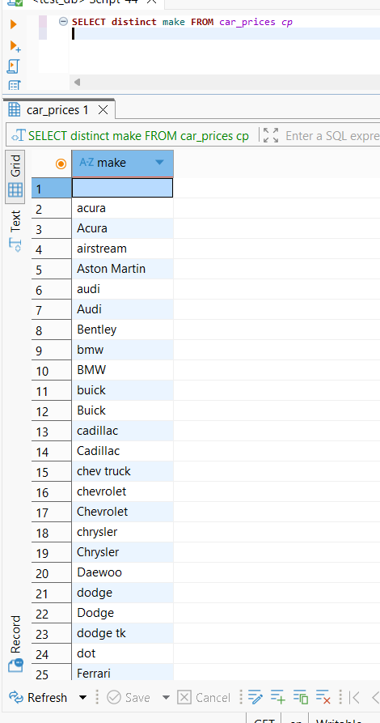
Figure 2 - Missing Values (Nulls/Blanks) in Critical Dimension "Make" (make column)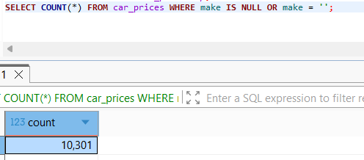
Figure 3 - Format Corruption: Vehicle Models Converted to Dates ("09-Mar", "09-May")
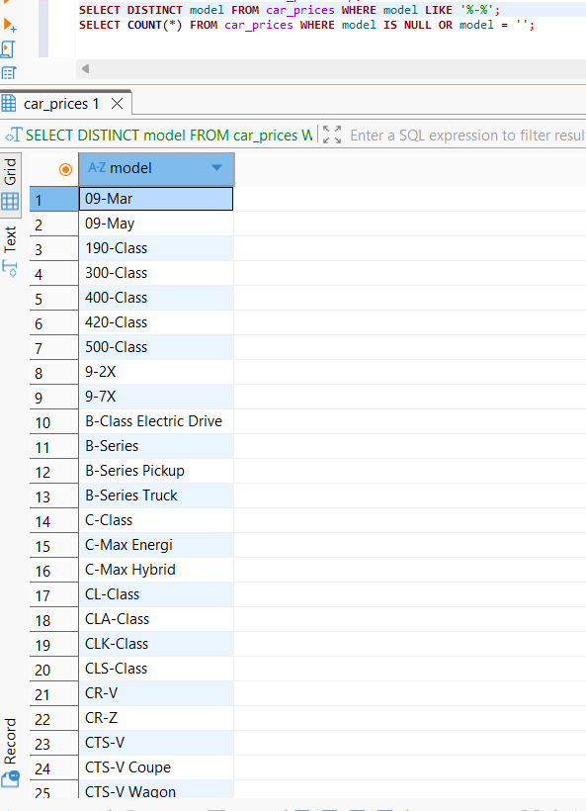
Figure 4 - Categorical Duplication via Lowercase Inconsistency in Models

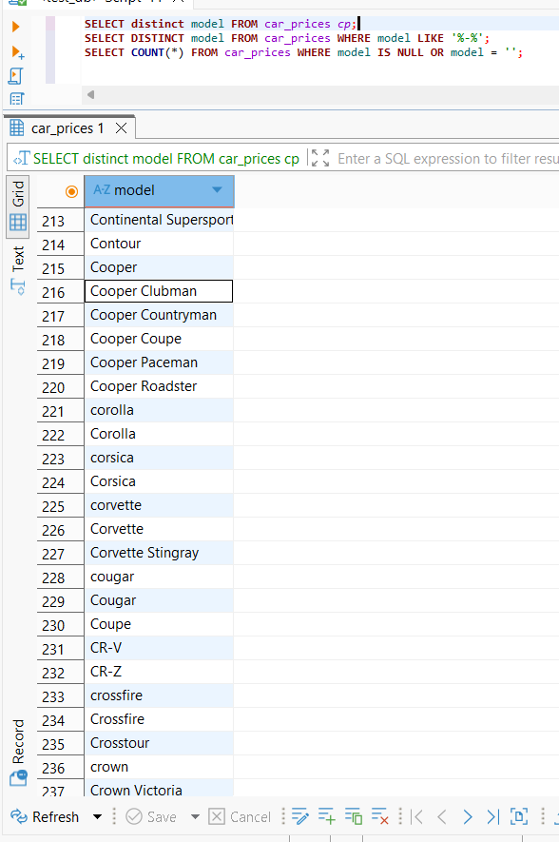
Figure 5 - Missing Values (Nulls/Blanks) in Critical Dimension Model
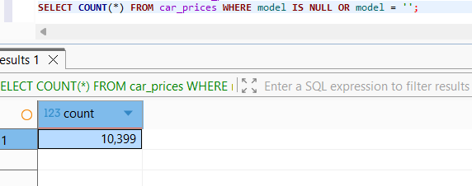
Figure 6 - Suspicious Data Truncation and Low-Character Artifacts (e.g., trim = "4")

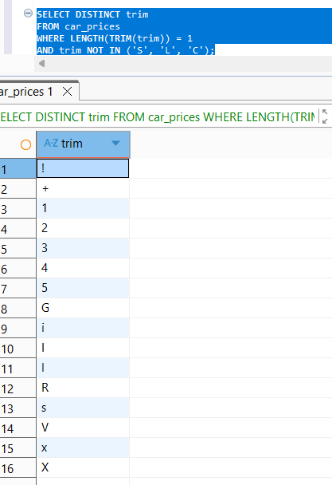
Figure 7 - Missing Values (Nulls/Blanks) in Critical Dimension trim
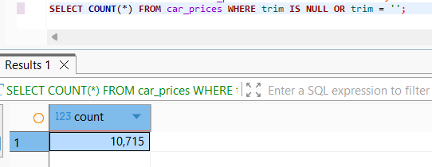
Figure 8 - Categorical Duplication via Lowercase Inconsistency in trim
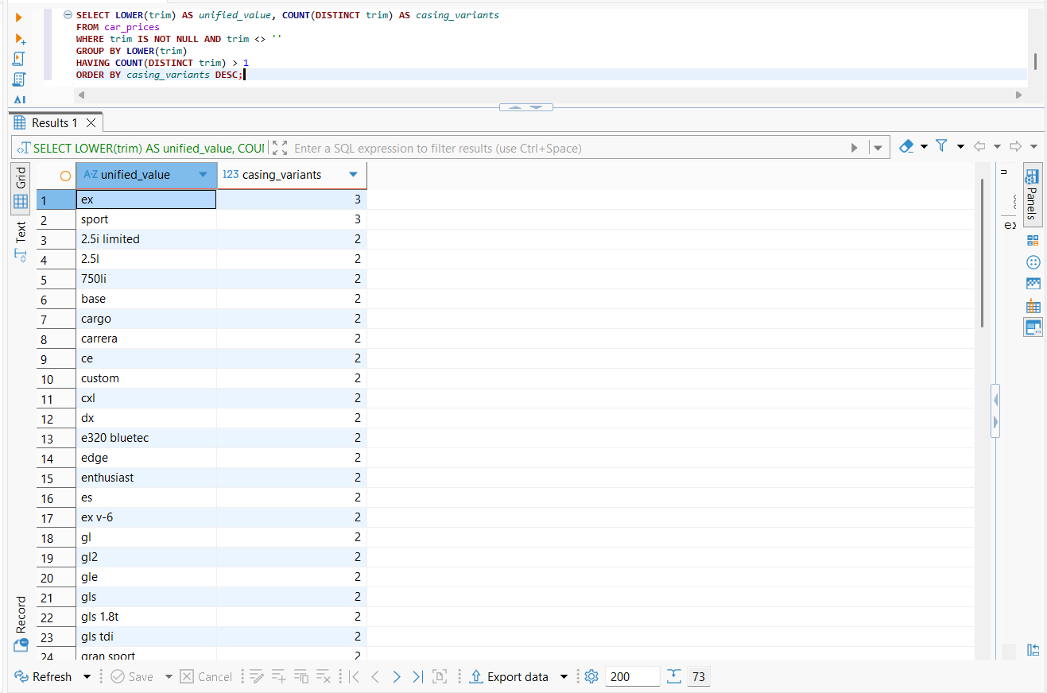
Figure 9- Missing Values (Nulls/Blanks) in Critical Dimension body
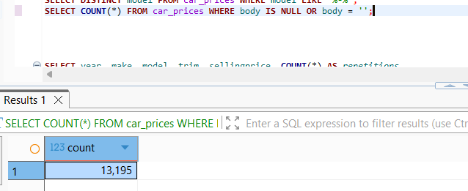
Figure 10- Categorical Duplication via Lowercase Inconsistency in body
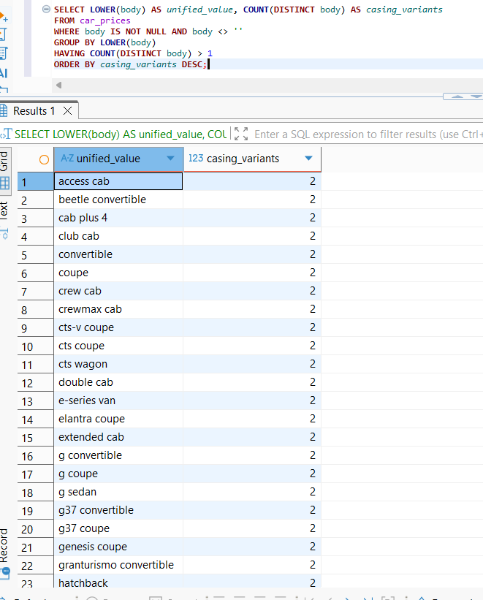
Figure 11- Logical Entity Anomaly in transmission column
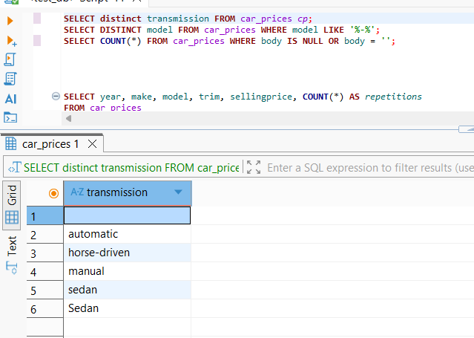

Figure 13- Missing Values (Nulls/Blanks) in transmission column
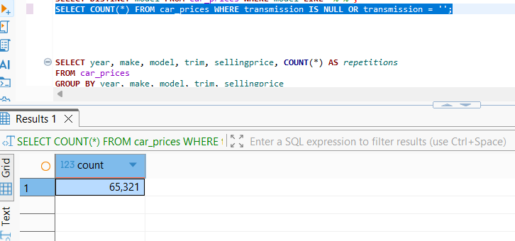
Figure 14- Critical Unique Entity Duplication (True VIN Overlaps)
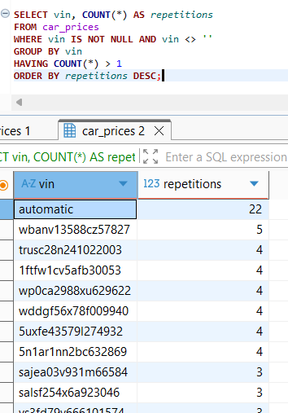

Figure 15- Critical Data Truncation and Low-Character Noise (Length = 3)
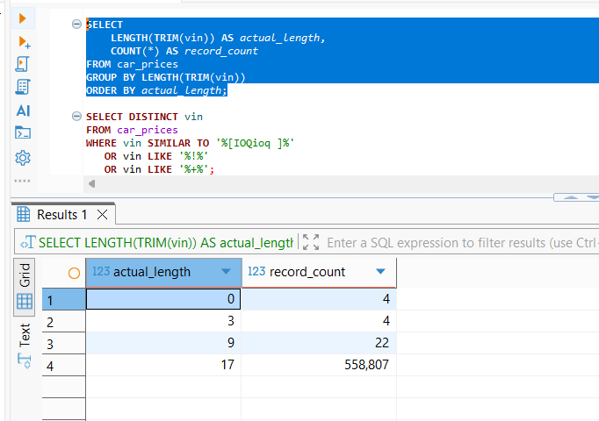
Figure 17 - Severe Structural Parsing Shift and Misaligned Values (vin = 'automatic')
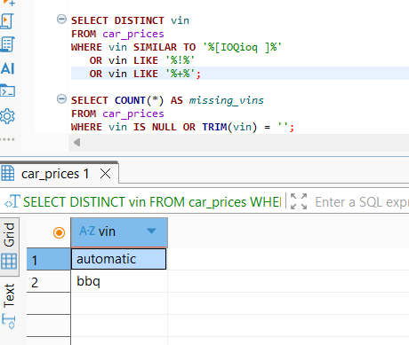
Figure 18- Critical Column Overflow and Delimiter Shift in Geography (state column)
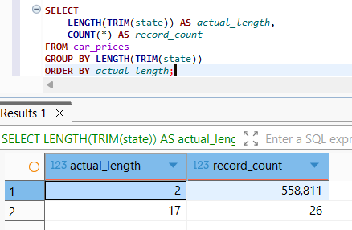
Figure 19- Systemic Scale Mixing and Out-of-Bounds Valuation Artifacts in condition column
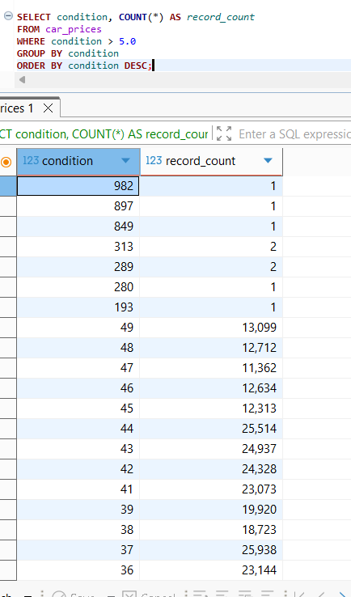
Figure 20- High Volume Data Completeness Violation (11,820 NULL Records in condition column)
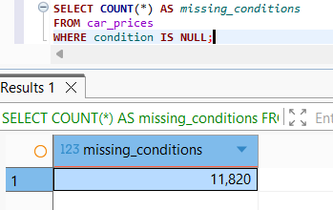
Figure 21- Low-Value Odometer Entries in odometer column

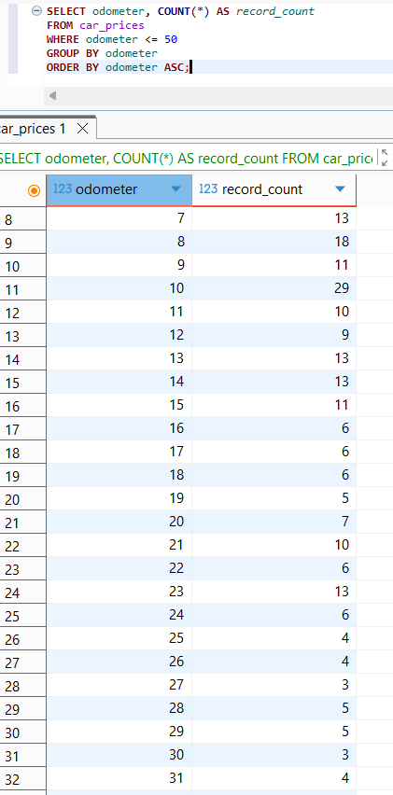
Figure 22- Technical Hardcoded Placeholder Corruption in odometer column
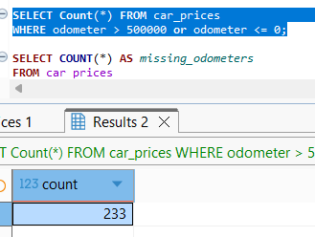
Figure 23- Odometer Completeness Failure (94 Missing Records)
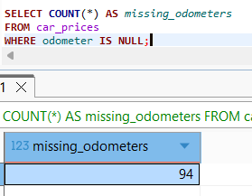
Figure 24- High-Volume Completeness Violation (25,434 Missing/Empty Values)
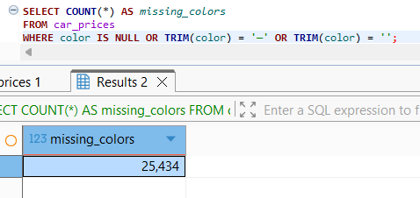
Figure 25- Numerical Infiltration and Structural Domain Contamination (26 Rows)
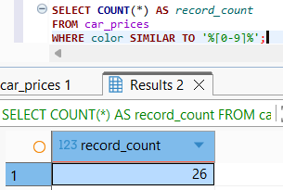
Figure 26- Data Completeness Violation in Interior Dimension
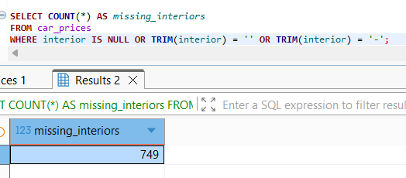
Figure 27- Suspicious Master Data Artifacts and Structural Noise in seller Column
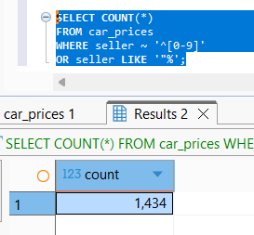

Figure 28- Abnormally Low Metric Boundary Thresholds (Mock/Placeholder Values in mmr)

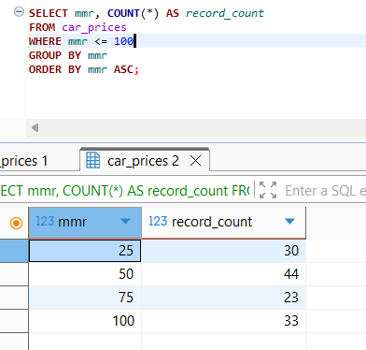
Figure 29- Data Completeness Failure (Missing Valuation Profiles in mmr)
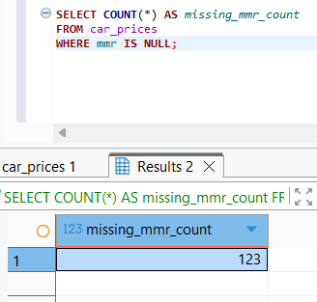
Figure 30- Suspicious selling price metrics lower 100
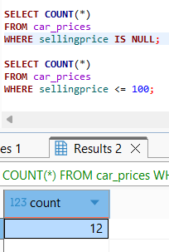
Figure 31- Data Completeness Failure (Missing Revenue Metrics in sellingprice)
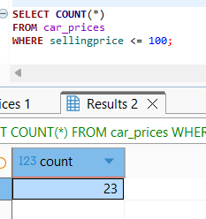
Figure 32- Structural Column Shifting and Pure Numeric Contamination in saledate
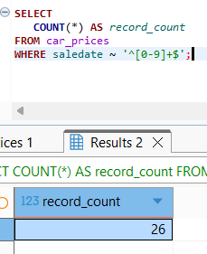
Figure 33- Data Completeness Failure (Missing Transaction Timestamps in saledate)
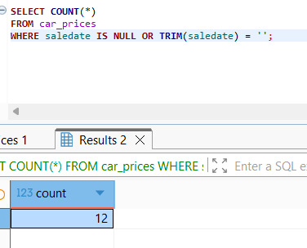
A comprehensive Data Quality (DQ) assessment was conducted on the provided Car Prices dataset using SQL to evaluate its structural integrity, transactional consistency, and readiness for subsequent Data Warehousing (DWH) architectural staging, ETL pipelines, and Power BI analytical modeling. The analysis revealed a significant volume of data anomalies, severe structural column-shifting defects, and system-generated placeholder artifacts across both numerical metrics and foundational categorical dimensions. Leaving these vulnerabilities unaddressed introduces compounding risks to gross margin reporting, inventory depreciation models, and dealer profiling engines.
To systematically isolate, profile, and quantify these data anomalies, advanced data profiling, programmatic regex matching, and exploratory data analysis (EDA) techniques were executed utilizing the PostgreSQL dialect inside the DBeaver enterprise environment:
- Regex Pattern Matching & Domain Testing: Applied native PostgreSQL regular expressions (~ '^[0-9]+$') to textual attributes to detect internal system key leaks, master data corruption, and numerical infiltration inside strictly descriptive dimensions like seller and saledate.
- Boundary Value Analysis (BVA) & Step Filtering: Scanned the extreme operational thresholds of critical financial and performance metrics (mmr, sellingprice, odometer), which successfully exposed hardcoded system default increments, artificial fallback values, and single-dollar mock records that violate fundamental automotive business logic.
- Structural Schema Alignment & Shift Detection: Inspected unique string layouts, character string lengths, and delimiter anomalies across structural fields to capture localized CSV parsing breakdowns, unescaped quotation noise, and cascade shifts where values overrode adjacent database headers.
- Completeness and Density Profiling: Evaluated the volumetric distribution of native NULL states, blank strings, and hidden textual placeholders (such as the dash — character) to measure overall field-level completeness and map gaps in essential commercial identifiers.

